**Simple School Management System (SMS)**.

This project aims to facilitate efficient management of educational institutions. Here’s a concise overview:

**Abstract:**

The **School Management System** is software designed to streamline administrative and academic operations within educational institutions. Here are the key points:

1. **Goal and Objectives**:
   * **Goal**: To create an efficient system for managing student information, attendance, exam schedules, and communication.
   * **Objectives**: Improve data security, enhance communication between teachers, students, and parents, and automate routine tasks.
2. **System Components**:
   * **Student Information Management**: Tracks student details, including enrolment, attendance, and performance.
   * **Teacher/Instructor Management**: Manages teacher assignments, qualifications, and class allocations.
   * **Room Management**: Allocates rooms based on student capacity per grade and section.
   * **Two-Way Interaction**: Facilitates communication between teachers and parents regarding student progress.
   * **Recognition Features**: Acknowledges outstanding student achievements in academics, sports, and cultural events.

**Software Requirements**:

* + **Front-End Frameworks**: Choose from technologies like **Angular** for the user interface.
  + **Back-End Services**: Develop backend services using **Java (Spring Boot),**
  + **Database**: Select an appropriate database system such as **MySQL**.
  + **Security**: Implement secure authentication and data protection.

[Remember, the School Management System aims to enhance efficiency, communication, and data security within educational institutions](https://www.studocu.com/in/document/chhatrapati-shahu-ji-maharaj-university/human-resource-management/school-management-system-project-abstract-pdf/48314709).

# System Configuration:-

# H/W System Configuration:-

# **Processor -** Intel(R) Core(TM) i5-6300U CPU @ 2.40GHz 2.50 GHz

Speed - 1.1 Ghz

RAM - 16 GB

Hard Disk - 20 GB

Key Board - Standard Windows Keyboard

Mouse - Two or Three Button Mouse

Monitor - SVGA

Creating Department for Students:

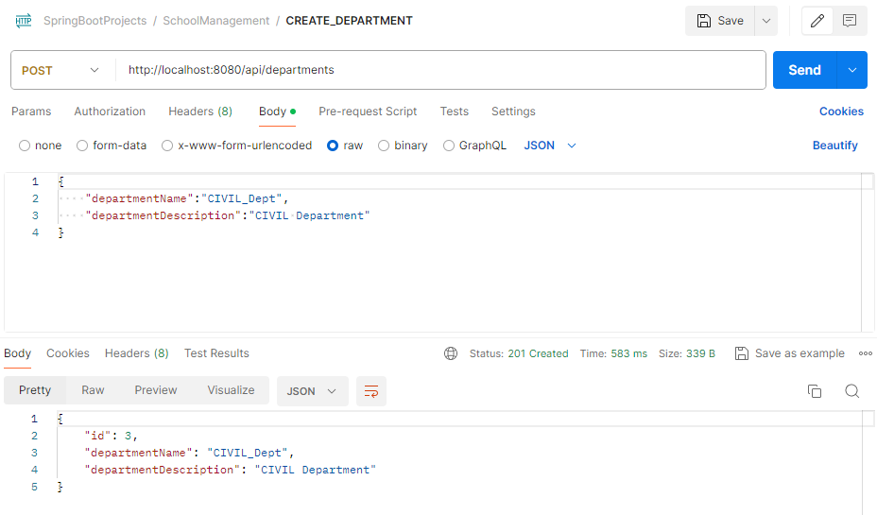

Creating Students for that Department: 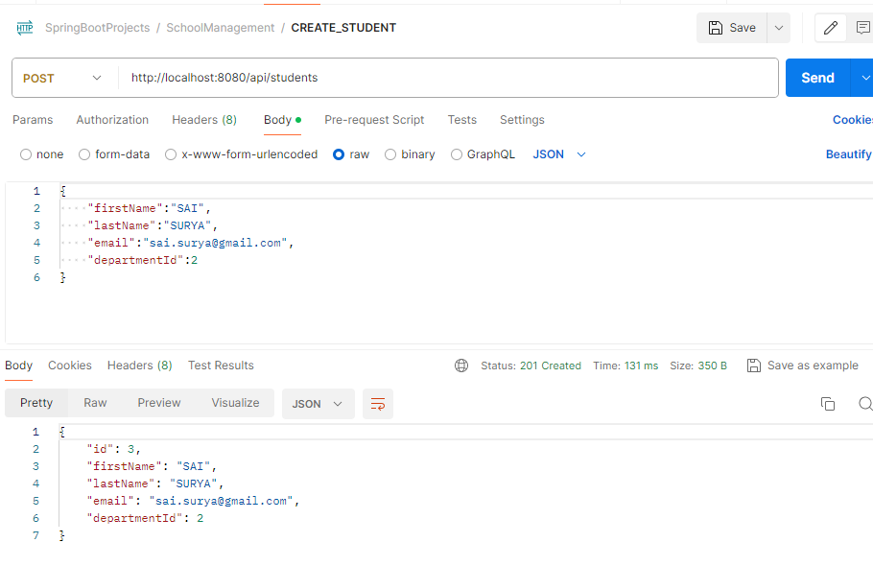

Fetch Student by Id: 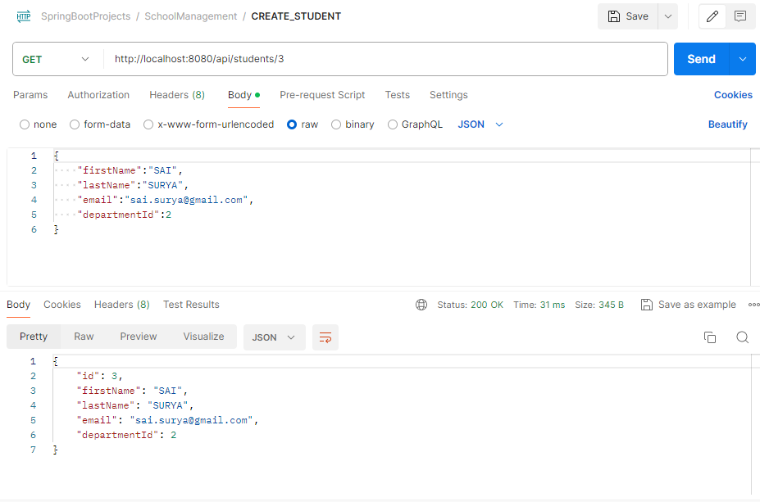

Fetch Deparment by Id